**Practical No 9**

**Name -: Aditya Babaso Birangaddi**

**Roll No -: 47**

**Enrollment No -: 1915770160**

**Sample Code-:**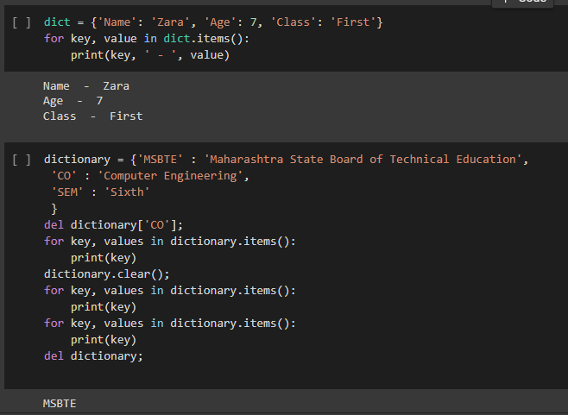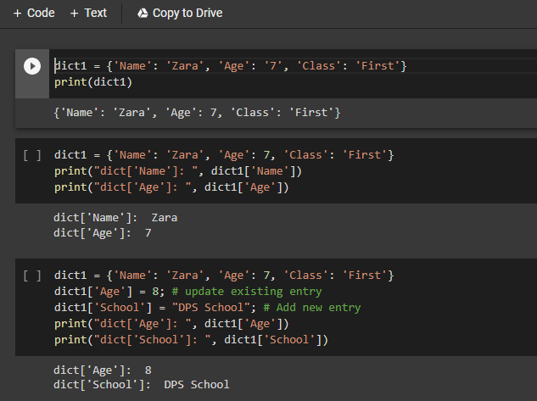

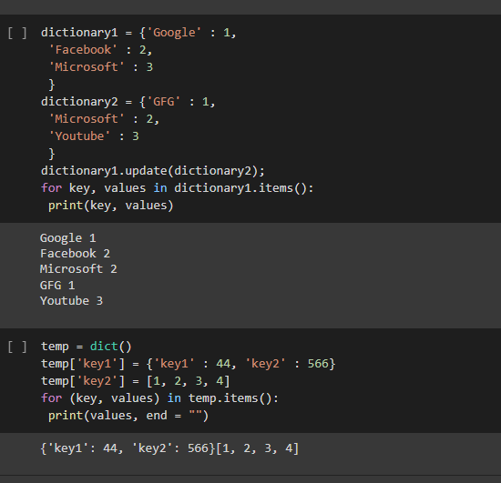

**1. Write a Python script to sort (ascending and descending) a dictionary by value**

**.**

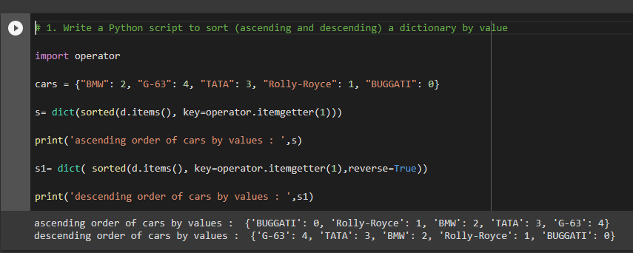

**2. Write a Python script to concatenate following dictionaries to create a new one.**

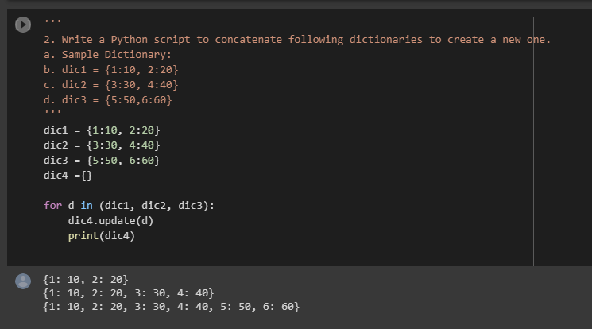

**3. Write a Python program to combine two dictionary adding values for common keys.**

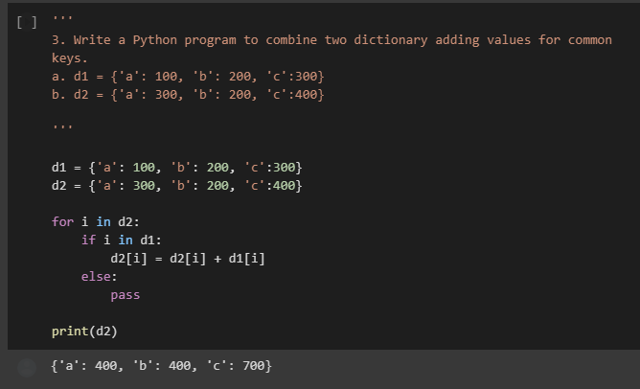

**4. Write a Python program to print all unique values in a dictionary.**

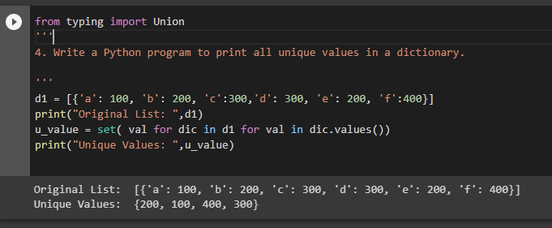

**5. Write a Python program to find the highest 3 values in a dictionary.**

